Park Entry Test Plan

**Revision History**

|  |  |  |  |
| --- | --- | --- | --- |
| **Rev** | **Date** | **Author** | **Description** |
| 1.0 | 1/16/2013 | Francisco Gonzalez | Release Version |

**Document Approvers & Sign-Off**

|  |  |  |  |
| --- | --- | --- | --- |
| **Date** | **Approver** | **Role** | **Document Accept/Reject** |
| 1/17/2013 | Mark Mecham | Synapse Test Manager |  |

**Contacts**

|  |  |
| --- | --- |
| Glenn Curtis | Disney Relations Manager |
| Tony Cowan | xGreeter Application Developer |
| Mike Broz | Project Management |
| Travis Pruitt | Developer |
| Arek Glabek | xBRC Developer |
| Slava Minyailov | xAG Developer |
| Iwona Glabek | xBRMS Developer |
| Greg Strange | Reader code |
| Corey Wharton | Reader code |
| Adam Parish | Disney |
| John McLean | QA |
| Rob Silvernagel | QA |
| Francisco Gonzalez | QA |

**Related Documents**

|  |  |
| --- | --- |
| 900-0063 IDMS Test Plan | The ID Management System (IDMS) stores and maintains information about park guests, making it possible to link external systems with the xConnect components. |
| 900-0071 xBRC Test Plan | xBand Reader Controller |
| 900-0072 xBRMS Test Plan | xBand Reader Management System |
| Park Entry Test cases | And Excel document Including xGreeter and High Availability (HA) test cases. |

**Table of Contents**

1 Background 5

2 Objective 5

3 UX Elements 6

4 In Scope 6

5 Schedule and Timeline 6

6 Testing Resources 7

7 Testing Environment 7

8 Test Metrics 7

9 Test Deliverables 8

10 Test Scenarios 8

11 Performance Testing 9

12 High Availability 11

12.1 Background 11

12.2 Objective 11

12.3 Network Architecture 11

12.4 In Scope 11

12.5 Schedule and Timeline 12

12.6 Setup instructions on xBRMS 12

12.7 Set up the Greeter App on the device (iPOD) 13

13 Test Scenarios 14

13.1 Pre-requisites (applicable to all scenarios): 14

13.2 Scenario 1 – Master unavailable when events are happening 15

13.3 Scenario 2 - Master unavailable before logging in 16

13.4 Scenario 3 – xBRMS unavailable 17

13.5 Scenario 4 – Device (iPOD) cannot reach the Wi Fi 18

13.6 Scenario 5 – a switch from Master to Slave happens when the device (iPOD) cannot reach the Wi Fi 19

# Background

The Greeter Application will be used by Disney cast members who are employed as either “greeters” or “greeter coordinators”. The greeters will be responsible for overseeing guests entering Disney properties such as Magic Kingdom or Epcot. Guests will possess a device (key card) that contains an RFID tag, which they will tap on a reader to identify themselves. The reader will flash green or blue depending on whether the guest entitlement check succeeded or failed.

Readers are assembled into locations. Typically, a greeter will be responsible for monitoring a single location that will typically consist of two readers.

Typically, a guest coordinator will be responsible for overseeing up to eight readers at a given time. The readers a given coordinator will be responsible for will be installed contiguously.

# Objective

The objective of Park Entry integration testing is to guarantee all components involved are functioning; guests have the best experience when tapping their cards on the reader, Greeters are able to manage locations, readers, and events and Greeter Coordinators are able to manage readers and Greeters.

# UX Elements

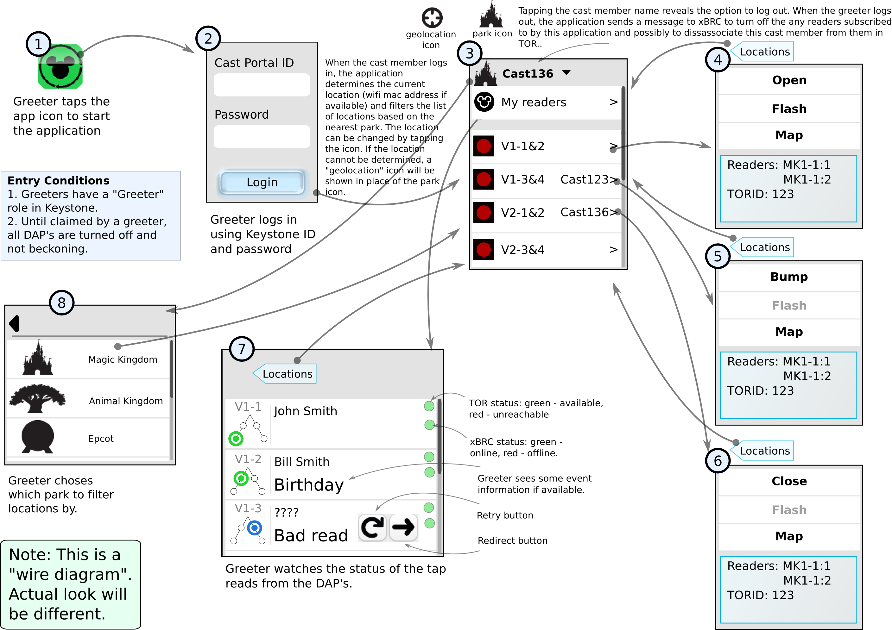

# In Scope

* Greeter Application
* As part of the Integration testing the following components will be tested along:
  + xTP – The device where guest tap the Fast pass card.
  + xBIO - the biometric (fingerprint) reader associated with the DAP reader.
  + xBRC – xBand Reader Controller (manages a set of readers.)
  + XBRMS – xBand Reader Management System (manages a set of xBRC’s.)
  + IDMS – ID Management System (handle the xBand metadata.)
  + Omni (The Park Entry authentication mechanism)

# Schedule and Timeline

**Tasks**

* Build Verification Test (BVT)
* Deployment to Test environment (Disney)
* Functionality
* User Interface
* Error Handling
* Training
* End To End
* Performance
* User Acceptance Test (xGreeter)
* Deployment to Production
* Go Live (xGreeter)

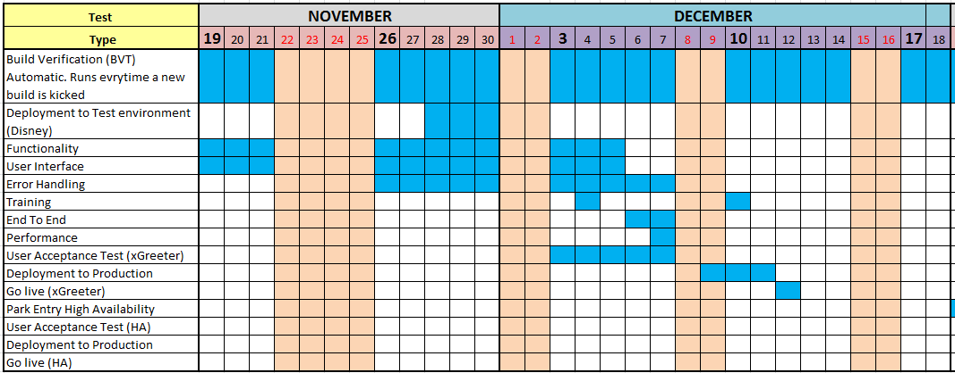

# Testing Resources

* Synapse
  + Rob Silvernagel
  + Francisco Gonzalez

# Testing Environment

* SIT in Seattle – A testing bench with virtual machines hosted in the Hyperchicken vmware server.
* Alpha Lab in Orlando (an environment with virtual machines managed by Adam Parish.)
  + Xbrcs: nl-flfa-00160, nl-flfa-00161

# Test Metrics

* Defects found by priority
  + Critical – Blocking, Major impact, must fix.
  + High - Impact on business, functionality broken.
  + Medium – Low impact on guest or client.
  + Low – Mostly cosmetic, little or no impact on business.

# Test Deliverables

* Test Plan (this doc)
* Test Cases (and Excel document including xGreeter and High Availability test cases)

# Test Scenarios

* Scenario 1
  + Configure two xTPs to point to xBRC in test environment
  + Configure xBRC to point to xBRMS in test environment
  + Configure Omni (or simulator) in test environment
  + Point to Keystone with real like users with different profiles (Greeter and Greeter Coordinator among them)
  + Download latest Park Greeter app to iPOD with iOS 6.0.1
  + Configure iPOD app to specific venue and xBRC configured above
  + Login as Greeter1
  + Open location with readers
  + Have 10 guests (fast pass cards) to tap on reader1 causing green event
  + Have 1 guest (fast pass card) to tap on reader2 and cause blue event
  + Greeter1 clears blue event
  + Greeter1 logs out
* Scenario 2
  + Configure two xTPs to point to xBRC in test environment
  + Configure xBRC to point to xBRMS in test environment
  + Configure Omni (not simulator) in test environment
  + Point to Keystone with real like users with different profiles (Greeter and Greeter Coordinator among them)
  + Download latest Park Greeter app to iPOD with iOS 6.0.1
  + Configure iPOD app to specific venue and xBRC configured above
  + Login as Greeter1
  + Open location with readers
  + Login as Greeter2
  + Greeter2 bumps Greeter1
  + Greeter1 logs out.
* Scenario 3
  + Configure three xTPs to point to xBRC in test environment
  + Configure xBRC to point to xBRMS in test environment
  + Configure Omni (not simulator) in test environment
  + Point to Keystone with real like users with different profiles (Greeter and Greeter Coordinator among them)
  + Download latest Park Greeter app to iPOD with iOS 6.0.1
  + Configure iPOD app to specific venue and xBRC configured above
  + Login as Greeter Coordinator
  + Greeter Coordinator Schedules Maintenance for reader1
  + Greeter Coordinator Schedules Bio maintenance for reader2
  + Greeter Coordinator Shuts Down reader3
  + Greeter Coordinator logs out.
* Scenario 4
  + Configure two xTPs to point to xBRC in test environment
  + Configure xBRC to point to xBRMS in test environment
  + Configure Omni (not simulator) in test environment
  + Point to Keystone with real like users with different profiles (Greeter and Greeter Coordinator among them)
  + Download latest Park Greeter app to iPOD with iOS 6.0.1
  + Configure iPOD app to specific venue and xBRC configured above
  + Login as Greeter Coordinator
  + Greeter Coordinator switches to Greeter role
  + Open location with readers
  + Guest causes a blue event
  + Clear blue event
  + Switches to Greeter Coordinator role
  + Log out
* Scenario 5
  + Attempt to login to Park Greeter app with not existing user in Keystone
  + Attempt to login to Park Greeter app with existing user in Keystone but with the wrong password
  + Attempt to login to Park Greeter app with user and password in Keystone but with role different that Greeter or Greeter Coordinator

# Performance Testing

Park Greeter Application response times will be dependent on a number of external dependencies and on the task being performed. The table below lists target response times for different features of the Park Greeter Application.

| **Feature** | **Maximum Acceptable Average Response Time (in ms)** |
| --- | --- |
| Login – the time since Cast Greeter taps on the Login button until he/she can perform another action (e.g. Open Location) | 5000 |
| Render latest DAP/reader event – the time that takes after a card tap and until the green / blue event is displayed on the device. | 1000 |
| Schedule reader/bio maintenance – the time that takes since Coordinator hits the Schedule reader/bio maintenance button until he/she can perform another action. | 2000 |
| Shutdown DAP/reader - the time that takes since Coordinator hits the Shutdown button until he/she can perform another action. | 2000 |
| Logout greeter – the time that takes since a greeter taps logout until the Login screen is rendered. | 2000 |
| Reset blue lane event – the time that takes since the Reset blue lane is tapped until user can perform another action. | 2000 |
| Render event detail display | 1000 |
| Application startup – the time since user taps on the xGreeter logo on the device until the Login screen renders. | 1000 |
| Back end system (xBRC) failover – the time that takes for the xGreeter app to determine that a problem happened and until user receives the error that location has a problem. | 30000 |

# High Availability

## Background

Version 1.5 of the Park Entry software introduces support for high availability (HA). The testing of the HA code and its rollout in FPT3 have demonstrated the importance of understanding how HA works and the importance of correctly configuring the xConnect system to assure that it works properly. This section provides instructions on how to setup HA in the Alpha Lab and provides test script that can be executed by users in Orlando.

## Objective

This document provides a high-level description of the Park Entry test strategy, setting up the test environment and provides a set of test scenarios that may be executed by users in the park as part of the User Acceptance Test (UAT)

## Network Architecture

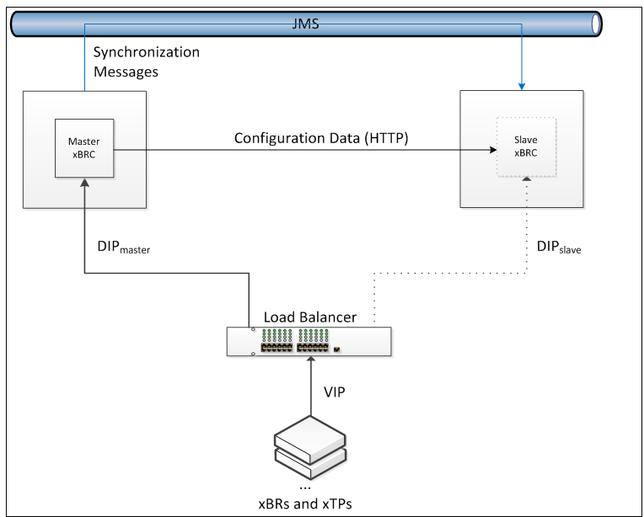

## In Scope

xBRC – xBand Reader Controller (Master and Slave)

xBRMS – xBand Reader Management System (to set up xBRC HA properties)

VIP – Virtual IP address – the address that will be used by the xGreeter application

## Schedule and Timeline

**Tasks**

Park Entry High Availability (Functionality)

User Acceptance Test (HA)

Deployment to Production

Go Live (HA)

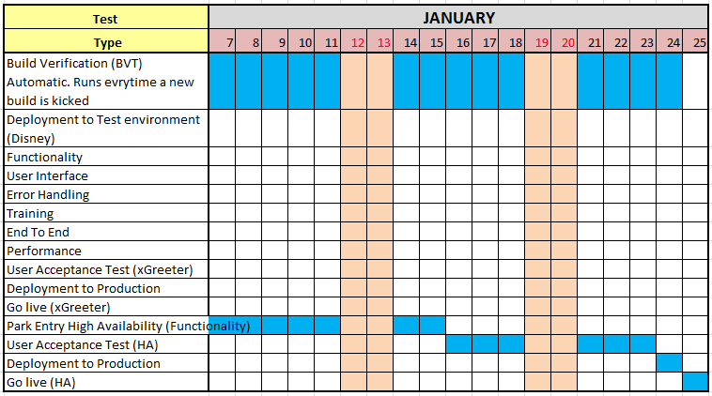

## Setup instructions on xBRMS

* Browse to xBRMS:

<http://nl-flfa-00095.wdw.disney.com:8080/XBRMS/>

* Browse to “Edit xBRC Properties”
* Click on the “PARKENTRY” tab
* Expand PE-Alpha Lab(10.92.65.171)
* Make sure following properties are set up as follows:

Enable HA = true



Venue = 11111111

Vipaddress = 10.92.65.249

Jmsdiscoverytimesec = 60

Jmssendintervalms: 1000

Jmstopic: XCONNECT.INTERACTIONS

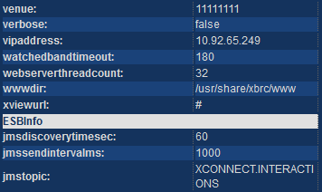

* Expand PE-Alpha Lab(10.92.65.172)
* Make sure following properties are set up as follows:

Enable HA = true



Venue = 11111111

Vipaddress = 10.92.65.249

Jmsdiscoverytimesec = 60

Jmssendintervalms: 1000

Jmstopic: XCONNECT.INTERACTIONS



* Restart xBRC 10.92.65.171
* Restart xBRC 10.92.65.172
* Refresh the xBRMS UI (<http://nl-flfa-00095.wdw.disney.com:8080/XBRMS/editxbrc>)
* Take a look of xBRCs in the right pane under PARKENTRY tab and verify:

One of the xBRCs configured above (nl-flfa-00160 or nl-flfa-00161) becomes the Master, the other becomes the Slave.

## Set up the Greeter App on the device (iPOD)

* Browse to xGreeter > Settings
* Make sure you have:
* Version: Latest (as of today we have 1.5 (33). If you do not have latest then go to Apps@Work and download it.
* Mode: Failover.
* Venue: the correct one (for instance Magic Kingdom or Alpha Lab).
* xBRC1 = the VIP (for Alpha Lab is http:// nge-rl-xbrc-pe1.wdw.disney.com:8080)
* User Directory: ed

# Test Scenarios

## Pre-requisites (applicable to all scenarios):

Setup xGreeter settings in the iPOD:

Mode: Failover

Venue: Alpha Lab

xBRC1: http:// nge-rl-xbrc-pe1.wdw.disney.com:8080

User Directory: ed

Under xBRMS have the following:

Xbrc1=10.92.65.171 HA enabled and with VIP=10.110.65.249

Xbrc2=10.92.65.172 HA enabled and with VIP=10.110.65.249

Xbrc1 the Master

Xbrc2 the Slave

## Scenario 1 – Master unavailable when events are happening

Login to the Greeter app in the iPOD  
Have guests actively tapping on the reader  
Have cast greeters monitoring taps (green/blue)   
Bring the master xbrc1 down

**Expected:**

Readers’ idle sequence is faster.

Greeter receives a message about location unavailable

After some time (about 15 seconds) xbrc2 becomes the master

Open location can be done (now BIP IP is talking to xbrc2)

Guests able to tap

Greeter able to monitor events

Bring xbrc1 up

**Expected:**

Xbrx2 is the Master

Xbrc1 is the Slave

## Scenario 2 - Master unavailable before logging in

Bring the master (xbrc1) down

**Expected:**

Xbrc2 becomes the Master

Xbrc1 is not available

Login to the Greeter app in the iPOD  
Have guests actively tapping on the reader  
Have cast greeters monitoring taps (green/blue)

**Expected:**

Guests able to get green and blue events

Cast greeter able to open locations and to monitor readers

Bring xbrc1 up

**Expected:**

Xbrc2 is the Master

Xbrc1 is the Slave

## Scenario 3 – xBRMS unavailable

Login to the Greeter app in the iPOD  
Have guests actively tapping on the reader  
Have cast greeters monitoring taps (green/blue)   
Bring the xbrms down

**Expected:**

Greeter app looks in the cache and finds master and slave (no switching)   
Guests able to tap

Cast greeter able to monitor readers

Bring the xbrms up

Wait for about 1 minute

**Expected:**

Guests able to tap

Cast greeter able to monitor readers

Xbrc1 is the Master

Xbrc2 is the Slave

## Scenario 4 – Device (iPOD) cannot reach the Wi Fi

Login to the Greeter app in the iPOD  
Have guests actively tapping on the reader  
Have cast greeters monitoring taps (green/blue)   
Have the iPOD w/o wireless (walk to a point where the Wi Fi is lost)

Attempt to Open/Close/Flash location

**Expected:**

Network Error

Return back to the place where Wi Fi is available

Wait until the iPOD connects to the Wi Fi

**Expected:**

Guests able to tap

Cast greeter able to monitor readers

## Scenario 5 – a switch from Master to Slave happens when the device (iPOD) cannot reach the Wi Fi

Login to the Greeter app in the iPOD  
Have guests actively tapping on the reader  
have cast greeters monitoring taps (green/blue)   
Have the iPOD w/o wireless (walk to a point where the Wi Fi is lost)

Attempt to Open/Close/Flash location

**Expected:**

Network Error

Bring the master (xbrc1) down

Xbrc2 becomes the Master

Xbrc1 is not available  
Return back to the place where Wi Fi is available

Wait until the iPOD connects to the Wi Fi

**Expected:**

Cast greeter able to open location (now BIP IP is talking to xbrc2)

Guests able to tap

Cast greeter able to monitor readers

Bring xbrc1 up

**Expected:**

Xbrc2 is the Master

Xbrc1 is the Slave